M

**Name: Mohsin Zeb**

**Intern ID:** **TN/IN02/PY/019**

**Email ID : mohsinzebsm@gmail.com**

**Domain: Python Development**

**Task no: Week #1**

**Question 1. Fix badly-indented code.**

**2. Add comments explaining each step**

Code and OUTPUT:

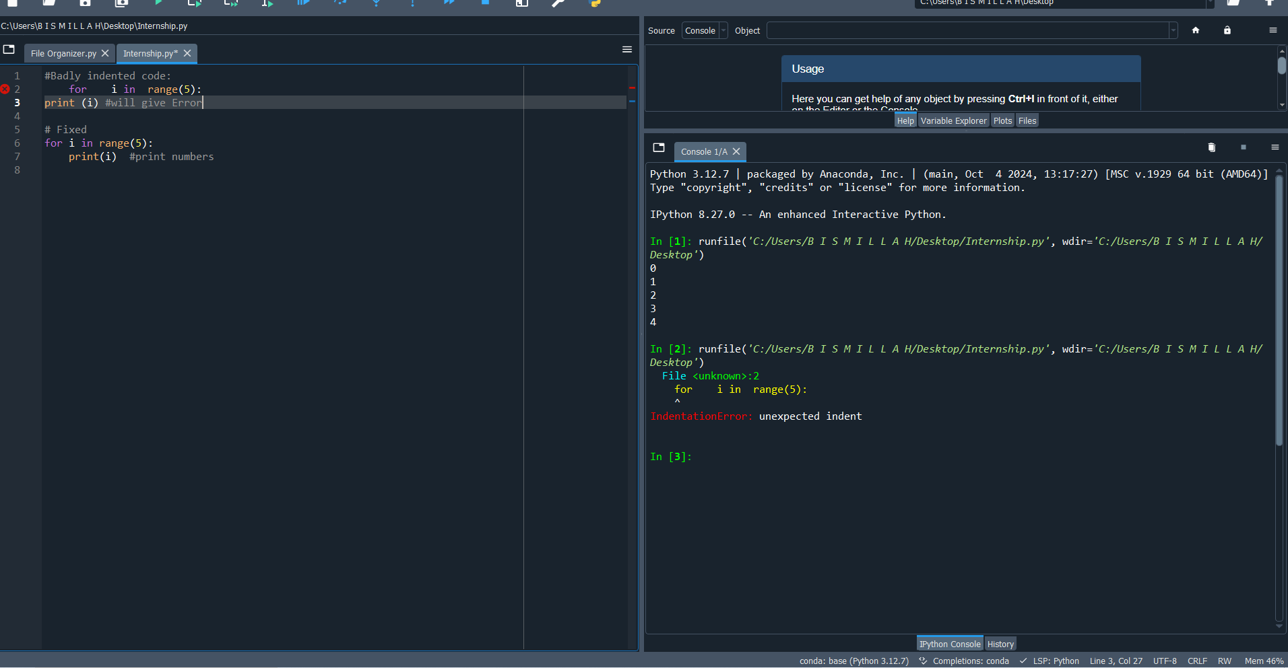

Learning:

1. Python uses indentation to define blocks of code.
2. Improper indentation causes syntax errors
3. Comments explain code to others and your future self.
4. Use # for single-line comments.

**Question: 1. Collect user profile & print typed summary.**

**2. Swap two variables without temp var.**

Code and OUTPUT:

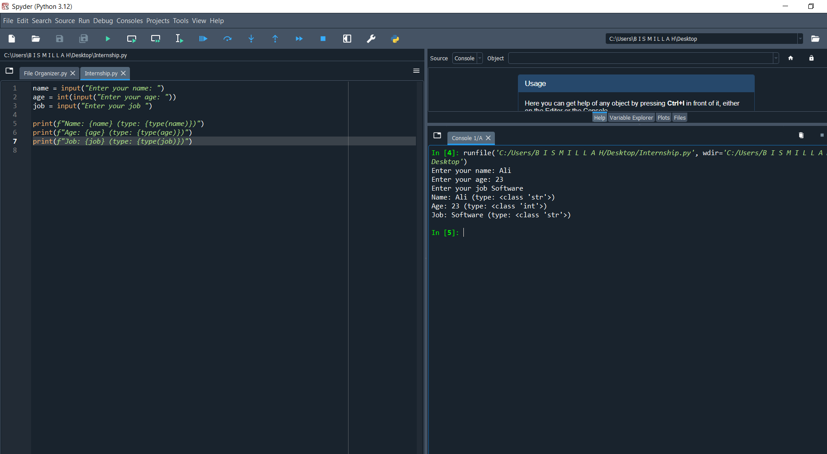

Learning:

1. Variables store different types of data (int, float, str).
2. Use input() to get user input.
3. Swapping doesn’t need a temp variable.
4. This method is clean and efficient.

**Question: 1. Read three numbers; output avg.**

**2. Convert minutes to hours + minutes.**

Code and OUTPUT:

Learning:

1. Always cast numeric input using float() or int().
2. Perform arithmetic operations using operators.
3. Useful for time-based calculations.

**Question: 1. BMI calc from user input.**

**2. Simple interest calc**

Code and OUTPUT:

Learning:

1. BMI calculator uses height and weight to measure body reference
2. BMI = weight / (height²).
3. Order of operations matters.
4. Financial formulas can be used

**Question: 1. Username builder from full name.**

Code and OUTPUT:

Learning:

1. .lower() converts to lowercase.
2. .split() breaks string into words.
3. ''.join() joins without spaces.

**Question: 1. Grade calculator.**

**2. Password strength classifier**

Code and OUTPUT:

Learning:

1. if-elif-else checks multiple conditions.
2. Order matters: first true condition runs.
3. Strong passwords need length
4. Logical operators (and, or) combine conditions

**Question: Multiplication Table**

Code and OUTPUT:

Learning:

1. range(start, end) generates numbers.
2. Loops are used for repetitive tasks

**Question:CLI Converter:**

Code and OUTPUT:

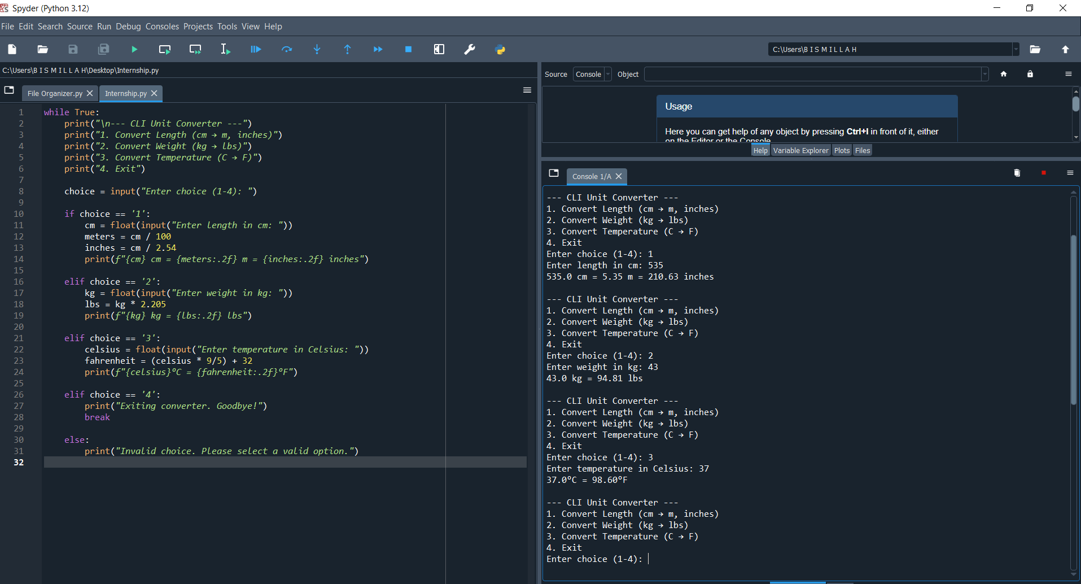

Learning:

1. Arithmetic operations can convert between units
2. Loops keep on repeating until certain conditions met
3. We can implement any calculator easily with Conditional statements